**Development Design /Architecture**

**Usecase Diagram**

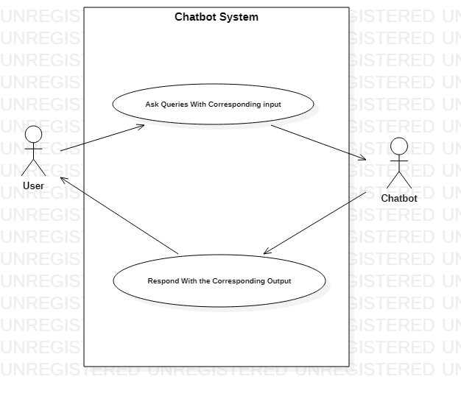

**Sequence Diagram**

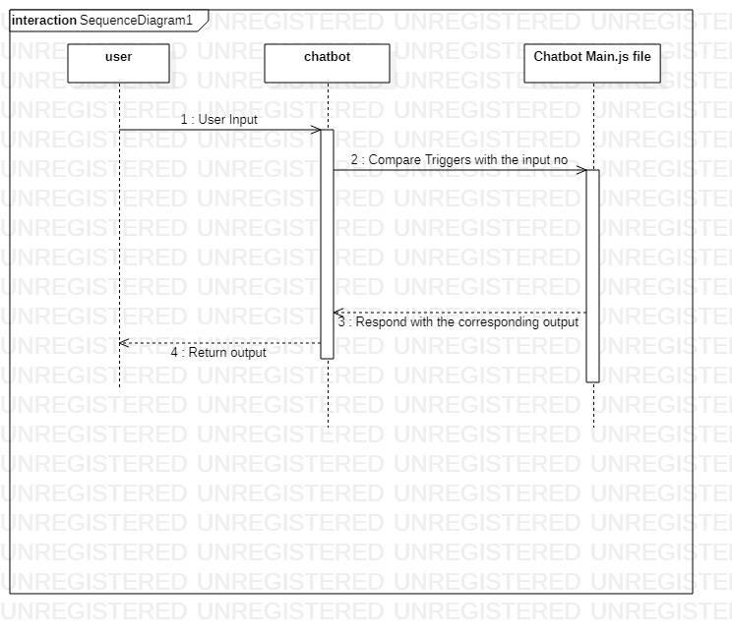

**Flow Chart Diagram**

